Authors’ name (use lowercase letters)

title of paper (capitalize)

Summary

In few sentences indicate the content of the paper

Povzetek
Please leave blank for the summary in Slovenian language

Introduction
You can continue with writing on the first page, if at least three lines of text remain on the first page. Use Times New Roman size 11 for regular text.
As an example of the desired layout of paper two sides of text appearance are enclosed. On the first page are authors or authors’ names, paper title, summary in English and blank space left for summary in Slovenian language. On the last page please include list of references and author’s address.
The paper with all of the appendices like tables and figures should not exceed 16 pages of DIN A4 pages. In formatting your original A4 page set left and right margin to 25 mm and top and bottom margin to 30 mm. Separate paragraphs with single blank line. Please do not number pages.
Please send MS Word (.doc or docx) version of paper to the following e-mail address: matej.kobav@fe.uni-lj.si.
Figures and pictures should be inserted directly in the text. Word Fig. and number should appear at the beginning of the explanation of the picture as shown on Fig. 1.
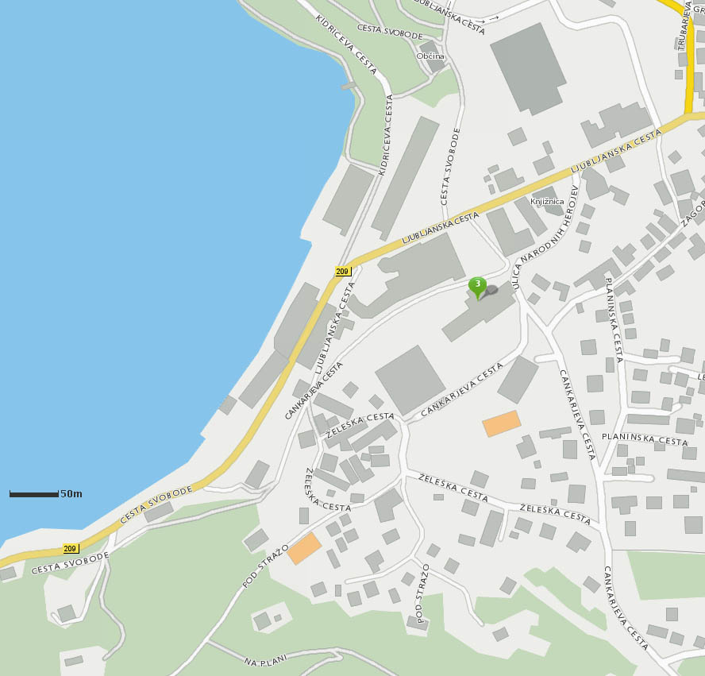
Fig 1: A sample case of an inserted picture.

It's similar with the tables; the only difference is that the legend for the table is before the table itself. As show with table 1.

Table 1: A sample case of an inserted table.
Cena za člane SDR | Cena/Price  (prijave do 20. septembra 2013) | Cena/Price  (prijave po 20. septembru 2013)
1. dan (kosilo, večerja, pogostitev med odmorom, zbornik) | 185 EUR | 205 EUR
2. dan (kosilo, pogostitev med odmorom, zbornik) | 115 EUR | 135 EUR
1. in 2. dan brez spanja | 230 EUR | 250 EUR

REFERENCES
[1]
[2]

Authors’ address
Andrej ORGULAN, MSc.
Faculty of Electrical Engineering and Computer Science Maribor
Smetanova 17
2000 Maribor
Slovenia
Email: andrej.orgulan@um.si,

